NEREIDS
Active camouflage for wild life photographers
Transformative Underwater Structures: Reimagining the Future of Coral Reef Conservation
The nereids are underwater structures, designed to safeguard coral reefs from the escalating threat of rising temperatures.
The structures provide active cooling for endangered areas over extensive durations, by harnessing the intrinsic properties of their materials.
Each structure is made up of a thermoresponsive, biocompatible hydrogel called NIPA.
As temperature rises, the gel undergoes a phase change, causing it to absorb heat, whiten and shrink.
This phase change enables the nereids to synergistically employ two cooling mechanisms.
Firstly, the active cooling of the gel itself - each gram of NIPA possesses the ability to cool down 10 grams of water by up to 1 degree Celsius. Secondly, leveraging the gel's transformative nature, I designed the structures to fold and encapsulate water within the gel sheets during each phase change. This strategic folding amplifies the cooling impact by creating a responsive geometry. In normal temperature, the leaves are open, allowing water to freely flow through them. When heated, the leaves contract, and fold - encapsulating cool water within them, forming a cooling vessel that maintains a balanced temperature over extended durations.

​
Turn video sound on
00:2702:49
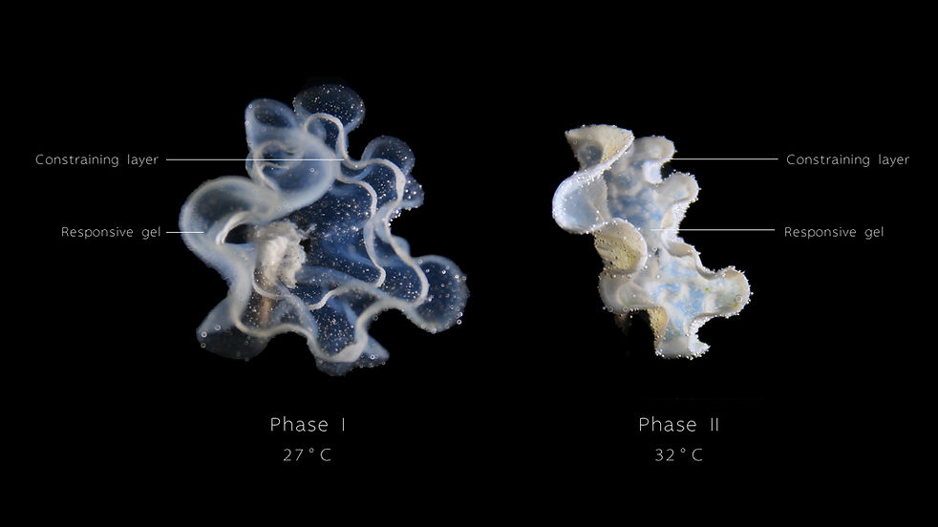
Programming thin sheets composed of gel and a constraining layer to exhibit heat-induced geometric variations.
As the NIPA gel shrinks when heated, while the constraining layer does not,
the thin sheet undergoes a transformative shift from 2D to 3D.
By altering the pattern of the constraining layer,
an array of customizable morphologies can be generated to meet specific design needs.

Similar to ice, when exposed to heat, NIPA gel undergoes a phase change, resulting in heat absorption, whitening, and shrinkage.
​
Each phase transition of NIPA allows it to exhibit a cooling capacity
of 1 degree Celsius per gram of gel for every 10 grams of water.
​
However, in contrast to ice, which undergoes a phase transition to a liquid state and disperses within the watery medium, NIPA gel remains in the form of a thin, coherent sheet after its phase transition. This unique property enables NIPA gel to be repeatedly activated for heat absorption upon encountering even slight temperature fluctuations within its watery environment.
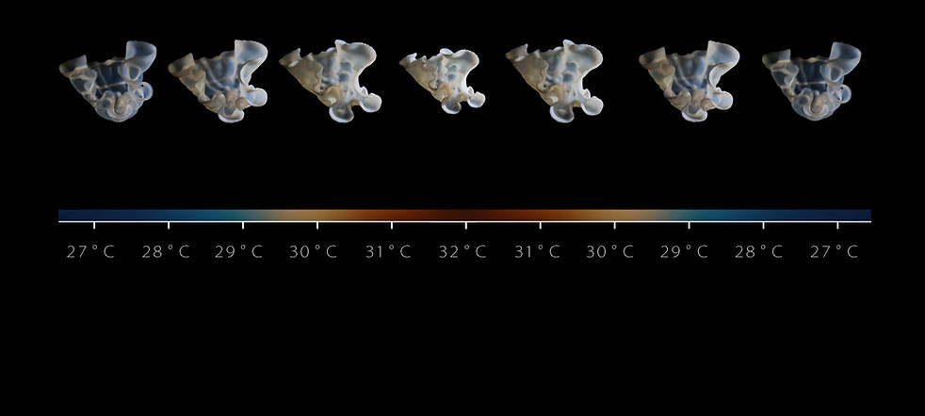
NIPA gel exhibits repeated phase changes in response to temperature fluctuations, transitioning between cooler temperatures (e.g., 27°C) and higher temperatures (e.g., 32°C). When immersed in the ocean, the gel can be continually reactivated by brief streams of cooler water, allowing for repeated cycles of heat absorption and geometric transformation.
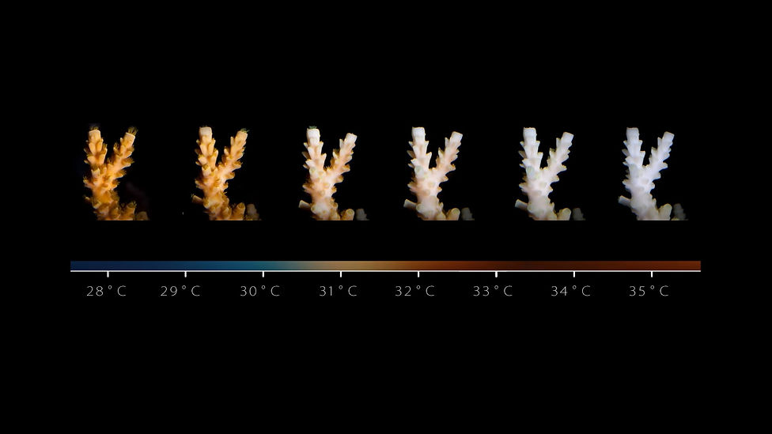
The phase transition temperature of NIPA gel, occurring at around 32°C, coincides with the emergence of another critical event. However, this particular occurrence brings with it a deeply concerning and potentially catastrophic consequence, posing a grave threat to one of the most vital ecosystems on Earth.
This phenomenon is commonly known as "Coral Bleaching," where coral species worldwide confront the consequences of rising ocean temperatures. As a result, they expel the essential algae residing within their cells, leading to irreversible damage and, in many cases, outright mortality.
​
Driven by the convergence of the two processes, I embarked on the quest to design underwater structures made up of NIPA gel that serve as local temperature balancers, protecting the coral reefs from the rising temperatures.

